Down To Meet

Software Requirements Specification

Version 1.0

Revision History

|  |  |  |  |
| --- | --- | --- | --- |
| **Date** | **Version** | **Description** | **Author** |
| 10/08/2020 | 1.0 | Software Requirement Specification  Document Initial Release | C2-G1 |

Table of Contents

1. Introduction 4

1.2 Purpose 4

1.3 Scope 4

1.4 Overview 5

2. Overall Description 6

2.2 Product Functions 6

2.3 User Characteristics 7

2.4 Constraints 7

2.5 Assumptions and Dependencies 7

3. Specific Requirements 8

3.1 Functional Requirement 8

3.2 Non-Functional Requirement 9

3.2.1 Usability 9

**Efficiency of use:** 9

3.2.2 Reliability 9

3.2.3 Performance 10

3.2.4 Security 10

3.3 Design Constraints 10

**3.3.1 Website must not have any dependency and must be lightweight:** 10

Software Requirements Specification

# Introduction

**1.1 User Story**

* Users can be a part of multiple groups or RSVP for any number of events as audience. Users can use this website to find friends, share a hobby, or for professional networking.
* User can create groups that host local in-person events as a organizer.
* Users can apply to become an instructor for a seminar/event.

## Purpose

* This website provides users to browse, create, and promote local events. It provides a platform for building a community for the upliftment of its members whether they be in a personal or professional context.

## Scope

* Registration/Login for audience, organizer, instructor.
* Profile, Dashboard for audience, organizer, instructor
* Audience:
  + Search Event
  + Book ticket
  + Event Details
  + Ticket History
* Organizer
  + Create Event (Select instructor if required)
  + Ticket Analytics
  + Show Event Layout
* Instructor
  + Apply for an event

## Overview

* The SRS will provide a detailed description of Down To Meet. This document will provide the outline of the requirements, overview of the characteristics and constraints of the system.
* **Section 2:** This section of the SRS will provide the general factors that affect the product and its requirements. It provides the background for those requirements. The items such as product perspective, product function, user characteristics, constraints, assumptions and dependencies and requirements subsets are described in this section.
* **Section 3:** This section of SRS contains all the software requirements mentioned in section 2 in detail sufficient enough to enable designers to design the system to satisfy the requirements and testers to test if the system satisfies those requirements.

# Overall Description

**2.1 Product Perspective**

The Down To Meet is used to connect with people who share your interests and organize events, it is a software to be used by community to digitalize the process for organizer, instructor and attendee. The Down To Meet to be developed benefits greatly the organizers and attendees. The attendee has to login to the system and search an event of his/her preference and check for the availability of free slots. The organizer can create an event and view his audience and select a mentor. The instructor can view events happening around him and can apply as an instructor for the event.

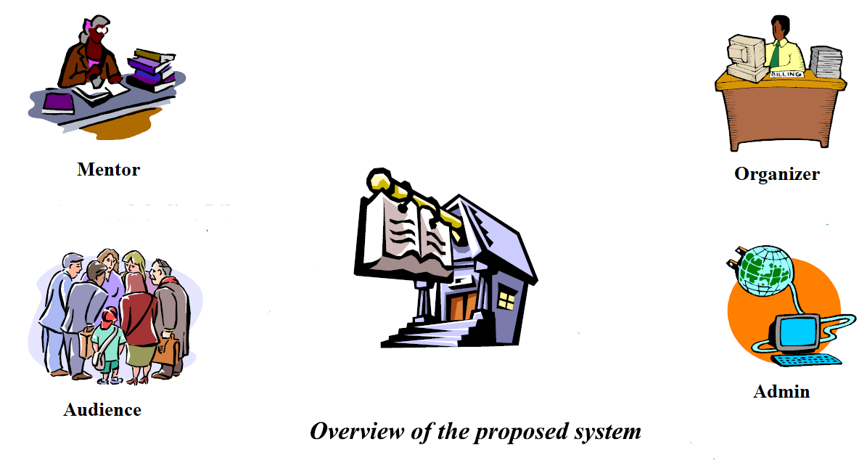

Figure 1 : Overview of Proposed System

## 2.2 Product Functions

**Down To Meet** provides a platform to organize online groups that host in-person events for people with similar interests.

1. Login for attendee, organizer, instructor
2. Attendee can see available slots for an event
3. User can be part of multiple groups of his/her preference
4. Organizer can create events and select mentor if needed
5. Organizer can analyze his event and.
6. Instructor can apply for an event.
7. Admin will verify the organizer and mentor

## 2.3 User Characteristics

The users of the system are attendee, instructor, and organizer. The users are assumed to have the basic knowledge of computer. The user interface of the website would be good enough to get to know the steps for the appointment and prescription.

## 2.4 Constraints

1. The information of all attendees, instructor (if any) should be stored in database that is accessible by Organizer.
2. The users can access Down To Meet from any computer that has internet connection.
3. The users must have correct username and passwords to enter access Down To Meet.

## 2.5 Assumptions and Dependencies

1. The users should have basic knowledge of computer.
2. The Users should have Internet connection and Internet server capabilities.

# Specific Requirements

* This Section describes all Functional as well as Non-functional requirements. It contains descriptions of functions and capabilities that the product must provide.

## 3.1 Functional Requirement

* Functional requirements describes how a product must behave*,* what its features and functions.

**F1: Authentication and Authorization**

* Login: The user can login to the website with his/her username and password.
* Input: Username and Password.
* Output: User Dashboard
* Processing: Verify username and password from database; if user exists in database then user interface will be displayed according to their role.
* Logout: The users can logout from system.
* Input: ‘Logout’ option is selected.
* Output: User login Screen will be displayed.
* Password reset: Users can reset their password.
* Input: Username/email
* Output: reset password page provided to user
* Processing: If user exists in database then mail will be sent to user through which users can reset their passwords.

**F2: Options for the Audience**

* Search Event:
* Input: Search keyword or query
* Output: List of events with attributes matching the search query
* Book Ticket:
* Input: ‘Book Ticket’ button for any event is selected.
* Output: Confirm ticket if slot is available.
* Event Details:
* Input: ‘Details’ button for the event is selected.
* Output: Display details about the selected event.
* Ticket History:
* Input: ‘Ticket History’ button is selected.
* Output: Display the history of tickets booked and events attended.

**F3: Options for the Organizer:**

* Create Event:
* Input: Content, Mentor and Location details
* Output: Event dashboard
* Ticket Analytics:
* Input: ‘Analytics’ button is selected
* Output: Ticket booking details are displayed
* Show Event Layout:
* Input: Select any organized event
* Output: Displays the event layout with edit options

**F4: Options for the Instructor:**

* Apply for an Event:
* Input: Search for an event and select ‘Apply as Instructor’
* Output: Displays the event details…

## 3.2 Non-Functional Requirement

## 3.2.1 Usability

* Usability defines how difficult it will be for a user to learn and operate the website.

### **Efficiency of use:**

* User can easily interact with website. User can easily access all the options without any help. It does not have complex design so any user can easily interact.

## 3.2.2 Reliability

* Reliability defines how likely it is for the website to work without failure for a given time period. Reliability decreases because of bugs in the code, hardware failures, or problems with other system components.
* The database update process must roll back all related updates when any update fails.

## 3.2.3 Performance

* Performance is a quality attribute that describes the responsiveness of the website to various user interactions with it.
* The website must be loaded quickly and should be smooth and interactive.

## 3.2.4 Security

* Security requirements ensure that the website is protected from unauthorized access to the system and its stored data. It considers different levels of authorization and authentication across different *users’* roles. For instance, data privacy is a security characteristic that describes who can create, see, change, or delete information.
* Unauthorized user cannot login to website.

## 3.3 Design Constraints

### **3.3.1 Website must not have any dependency and must be lightweight:**

* The website must not have any dependency, which means it must be compatible with all the browsers and should be responsive to the devices of all the sizes.
* It must be light weight so user doesn’t have to wait much or face any difficulty in attending or organizing event.